PPE Project 2.0 — Federated Learning POC Handoff Plan
Repository: Kailash-Murali/ppe-project-2.0
Base checkpoint: backend/best.pt (11-class YOLO, SHA256-pinned)
Goal: Demonstrate federated averaging across two simulated zone nodes, beating both solo-trained baselines on cross-zone accuracy, without centralizing raw images.

Role Assignment
Role | Person | Owns
Lead / Integrator | You | Repo structure, checkpoint distribution, final comparison, demo assembly, OpenVINO re-export
Data & Training | Teammate A | Zone A/B datasets, two solo-trained checkpoints, baseline metrics
Federated Infra | Teammate B | Flower server/client, FedAvg loop, round-by-round metrics

Phase 0 — Day 0 (You, before handing off anything)
Objective: Freeze the shared starting point so nobody trains from a different checkpoint by accident.
- Confirm backend/best.pt is the intended baseline (not best_openvino_model/ — that format is inference-only and cannot be fine-tuned or federated).
- Compute and distribute the hash:
sha256sum backend/best.pt > CHECKPOINT_HASH.txt
- Share CHECKPOINT_HASH.txt, the 11-class list from backend/best_openvino_model/metadata.yaml, and this document with both teammates.
- Create two empty branches: feature/zone-training (Teammate A) and feature/fedavg-infra (Teammate B), both cut from main.
- Post the class list in the team channel verbatim — this is the single most common silent failure point in federated setups:
0: boots 4: no boots 8: no vest
1: glasses 5: no glasses 9: person
2: gloves 6: no gloves 10: vest
3: helmet 7: no helmet
Exit criterion: Both teammates have the same best.pt hash and the same class list before either writes a line of training code.

Phase 1 — Days 1–3 (Parallel work, no dependency between A and B)
Teammate A — Data & Solo Training
Day | Task | Deliverable
1 | Split existing training images into data/node_a/ and data/node_b/ by recording session/camera angle (not random shuffle) | Two folders, images/{train,val}, labels/{train,val}
1 | Write data/node_a/data.yaml and data/node_b/data.yaml using the frozen 11-class list | Two data.yaml files
2 | Train Node A: yolo detect train model=backend/best.pt data=data/node_a/data.yaml epochs=15 imgsz=640 batch=8 seed=42 name=nodeA_local project=fed_baseline | fed_baseline/nodeA_local/weights/best.pt
2 | Train Node B: same command, data/node_b/data.yaml, name=nodeB_local | fed_baseline/nodeB_local/weights/best.pt
3 | Run all 4 validation combinations (own-zone + cross-zone) for both checkpoints | A CSV with 4 mAP50/mAP50-95 rows — this is the artifact everyone else waits on

Push to: feature/zone-training. Notify: You + Teammate B when the CSV lands.
Teammate B — Federated Infra (built and tested without waiting on real data)
Day | Task | Deliverable
1 | Install flwr, confirm Ultralytics YOLO loads via YOLO("backend/best.pt", task="detect") | Working local environment
1–2 | Write fed_client.py wrapping get_parameters/set_parameters/fit/evaluate around the model | fed_client.py
2 | Write fed_server.py with FedAvg(min_fit_clients=2, min_evaluate_clients=2) | fed_server.py
2–3 | Dry-run the whole pipeline on Ultralytics' bundled coco8.yaml sample dataset — do not wait for Teammate A | Two client processes + one server process completing 2 rounds without error
3 | Log round-by-round metrics to CSV (round, client_id, local_loss, mAP50) | fedavg_dryrun_log.csv

Push to: feature/fedavg-infra. Notify: You when the dry run completes cleanly.
Hard dependency check for Teammate B: FedAvg operates on model.model.parameters() tensors from the PyTorch best.pt checkpoint, never the OpenVINO IR. If model loading fails, the fallback logic already exists in backend/inference.py's load_model() — read it before debugging from scratch.

Phase 2 — Day 4 (Convergence point — the one moment both branches must sync)
This is the single dependency in the whole plan. Everything before this is parallel; everything after this needs both branches merged.
- You merge feature/zone-training and feature/fedavg-infra into a feature/fedavg-live branch.
- Teammate B swaps coco8.yaml in fed_client.py for data/node_a/data.yaml (Client 1) and data/node_b/data.yaml (Client 2).
- Teammate A stays on standby during this swap to answer any dataset-format questions immediately — don't let this become an async back-and-forth over chat.
- Run one real end-to-end round on real data before committing to a full 5–10 round run, to catch path/format errors cheaply.
Exit criterion: One successful FedAvg round on real zone data, with a global model checkpoint written to disk.

Phase 3 — Days 5–6 (Real federated run + comparison)
Owner | Task
Teammate B | Run 5–10 full FedAvg rounds; log mAP50/mAP50-95 per round to CSV
Teammate A | Stay available to re-check dataset labels if federated accuracy looks anomalously low on one zone
You | Once the global checkpoint is ready, run the four-way comparison: Node A solo, Node B solo, centralized-pooled (train once on both datasets merged, for reference only), and the FedAvg global model — all evaluated on the same held-out validation images

The number that matters: FedAvg global model's cross-zone accuracy should exceed both solo models' cross-zone accuracy and approach (not necessarily match) the centralized-pooled baseline.

Phase 4 — Day 7 (Your task — Integration & Demo)
- Export the final FedAvg global checkpoint back to OpenVINO IR for the live demo, mirroring the existing backend/best_openvino_model/ export step.
- Swap it into backend/ following the same file layout inference.py already expects — no code changes needed if the export uses the same filenames.
- Run the live PPE detection dashboard (frontend/) against the new federated model to confirm end-to-end inference still works with the FastAPI /ws pipeline.
- Assemble the final comparison table (solo A, solo B, centralized, federated) into the demo narrative.

Communication Protocol
- Daily 10-minute sync (async message is fine): each person posts one line — "on track" / "blocked on X" / "done, pushed to branch Y."
- No branch merges without the CHECKPOINT_HASH.txt check — if any checkpoint's hash doesn't match, stop and find out why before training on top of it.
- Single source of truth for the class list: the 11 classes live in one place (metadata.yaml); nobody retypes them into a new file without copy-pasting.
Risk Log
Risk | Owner most exposed | Mitigation
Teammate A's zone split accidentally leaks near-duplicate frames into both train/val | Teammate A | Split by recording session, verify no two "adjacent" frames land in different splits
Teammate B's FedAvg averages OpenVINO-exported weights instead of PyTorch best.pt weights | Teammate B | Dry run must use .pt, verified before Day 4 sync
Real data federated run gives worse accuracy than solo — non-IID mismatch too severe | Everyone | Fall back to reporting the gap honestly + showing solo vs. centralized vs. federated as three genuine data points, not hiding a bad number
Day 4 sync slips because Teammate A's baseline CSV isn't ready | You | Teammate B's dry run absorbs the slack — infra is already tested, so a 1-day data delay doesn't block infra work

Definition of Done
- [ ] Both solo checkpoints trained from identical best.pt, hash-verified
- [ ] Cross-zone degradation documented (the reason FedAvg is needed)
- [ ] FedAvg dry run passes on dummy data before real data is wired in
- [ ] At least 5 real FedAvg rounds completed on Zone A/B data
- [ ] Four-way comparison table (solo A, solo B, centralized, federated) produced
- [ ] Federated global model re-exported to OpenVINO and confirmed working in the existing FastAPI + React dashboard

Appendix
Paper
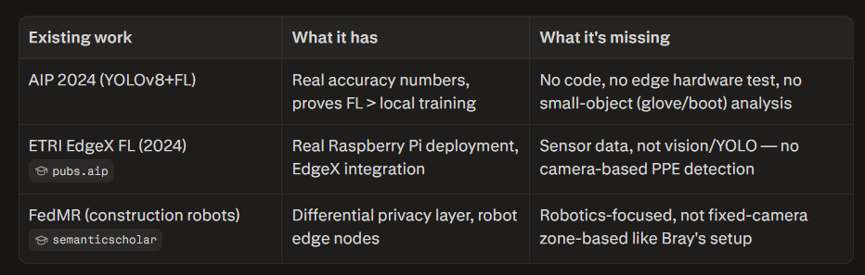

https://pubs.aip.org/aip/acp/article-abstract/3220/1/050006/3315947/Detecting-personal-protective-equipment-PPE?redirectedFrom=PDF
https://www.semanticscholar.org/paper/Collaborative-Worker-Safety-Prediction-Mechanism-in-Moe-Kim/ef55d2d64802f652265385c4976e7bf2a005ba73/figure/3
Dataset
https://universe.roboflow.com/ppe1-ppe2/ppe-cpxsz (dont use)
https://universe.roboflow.com/kailash-murali-t-23bai1427/ppe-construction-india

